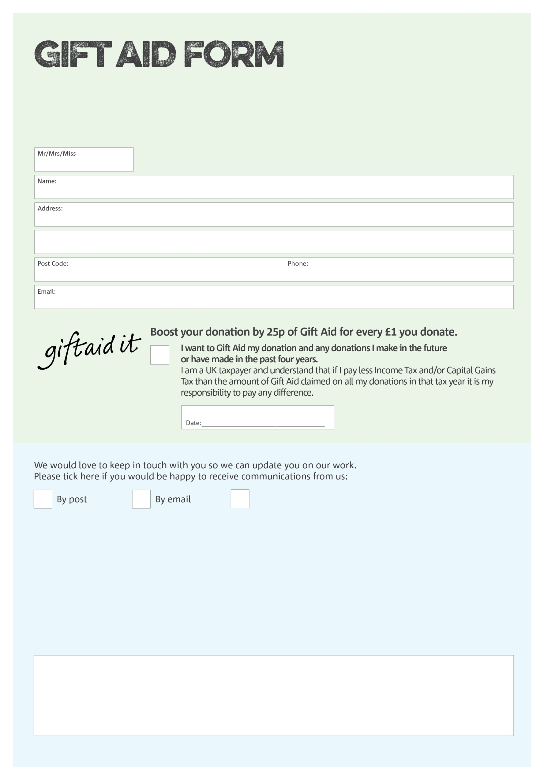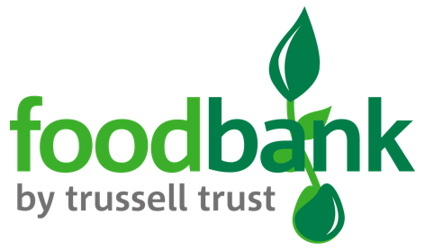

By filling in this form South Ayrshire Foodbank will receive an extra 25p for every £1 you give at no extra cost to you. Thank you!

We would love to know why you have chosen to donate to South Ayrshire Foodbank. If you would like to share your motivation let us know below:

**Data protection**

Data protection

'South Ayrshire Foodbank is committed to protecting your privacy and will process your personal data in accordance with current Data Protection legislation. South Ayrshire Foodbank collects information to keep in touch with you and supply you with information relating to our work. To unsubscribe from our newsletter, send a message to the email address above with the word unsubscribe in the subject line. A full data privacy statement for financial donors is available from the foodbank on request.’

You can change your preferences any time by contacting us on 07599071114 or emailing us at info@southayrshire.foodbank.org.uk

I do not wish to receive future communications from XXXX Foodbank

Charity Number SCIO44413. Registered in Scotland