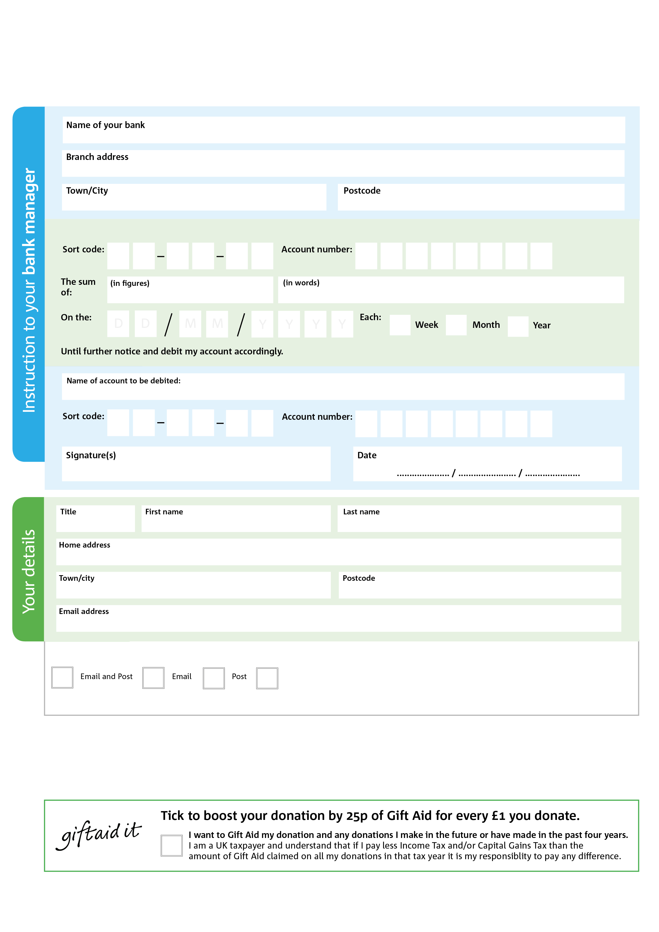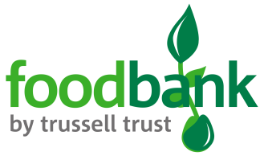

**Data protection**

Data protection

'South Ayrshire Foodbank is committed to protecting your privacy and will process your personal data in accordance with current Data Protection legislation. South Ayrshire Foodbank collects information to keep in touch with you and supply you with information relating to our work. To unsubscribe from our newsletter, send a message to the email address above with the word unsubscribe in the subject line. A full data privacy statement for financial donors is available from the foodbank on request.’

POSTAL ADDRESS:South Ayrshire Foodbank,New Life Centre, 62 Monkton Road, Prestwick KA9 2PA

Registerd Charity No. SCIO44413 Registered in Scotland

**Please pass this form onto the foodbank, using the foodbank’s address at the bottom, who will save a copy for their records. They will then send it onto your named bank or building society.**

8

V

6

V

5

V

4

V

1

V

5

V

7

V

7

V

0

6

7

3

7

8

We would love to keep you up to date with information about South Ayrshire Foodbank. Please tick your preference:

You can change your preferences any time by contacting us on 075990711114 or emailing us at info@southayrhsire.Foodbank.org,uk

I do not wish to receive future communications from South Ayrshire Foodbank

Please pay South Ayrshire Foodbank,

**Standing Order Mandate**

**South Ayrshire.foodbank.org.uk**

Reg. Charity No: xxxxxx | Reg. in England & Wales

You can change your preferences any time by contacting us on XXXXXXXXXXX or emailing us at XXXX@XXXXXXXXXX.foodbank.org.uk

I do not wish to receive future communications from XXXXXX Foodbank